**History of DHL Express (Philippines), Inc.**

Early Beginnings and Growth in the Philippines  
DHL Express, a global leader in logistics and express delivery services, began operations in the Philippines in the 1970s. It quickly established itself as a major player in international shipping and logistics, connecting the Philippines to global markets. Its expansion was driven by the growing demand for fast and reliable courier services amidst the country’s increasing integration into the global economy.

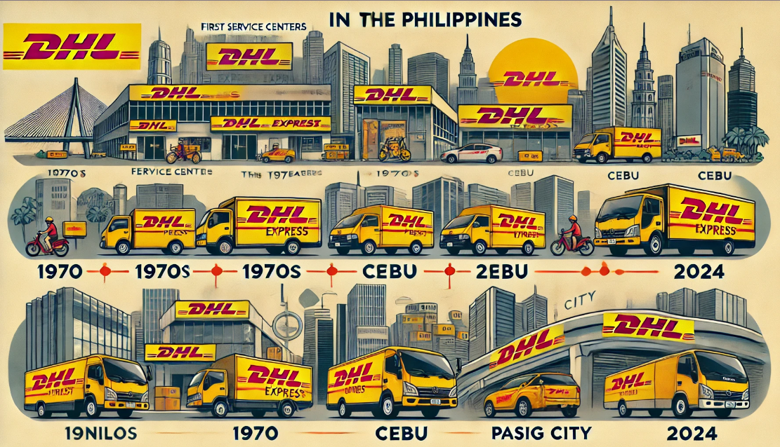

**1970s: Entry into the Philippines**

* DHL began its operations in the Philippines as part of its expansion into Asia, offering express document and parcel services.
* The company started with a few service centers in Metro Manila, addressing the growing demand for international courier services.

**1980s-1990s: Strengthening Regional Presence**

* As globalization progressed, DHL expanded its operations in key cities such as Cebu and Davao.
* It became known for its reliable connections to major global trade hubs, solidifying its leadership in international logistics.

**2000s: Investment in Technology and Infrastructure**

* DHL introduced advanced tracking systems and modernized its facilities in the Philippines.
* The company integrated digital tools to streamline customs clearance and shipment tracking, ensuring efficiency for businesses and consumers.

**2010s: Expanding Services and Sustainability Initiatives**

* DHL launched more localized solutions to meet the demands of Philippine SMEs and e-commerce businesses.
* In 2019, a dedicated air route between Manila, Cebu, and Hong Kong was established to enhance cargo handling capabilities

**Infrastructure Investments**: In 2023, DHL opened a 4,768-square-meter facility in Pasig City. This service center included warehouses, advanced material handling equipment, and a customer retail outlet to support the surge in e-commerce logistics.

**Sustainability Efforts**: In 2024, DHL introduced electric vehicles to its Philippine fleet, demonstrating its commitment to environmental sustainability. This initiative was part of a broader global push to achieve net-zero emissions by 2050​

**Modern Operations and Future Plans**  
As of 2024, DHL Express operates as the market leader in the Philippine express delivery sector. It continues to expand its aviation network and service infrastructure to meet rising parcel volumes. The company plans further investments in facilities and technology to sustain its growth and enhance service quality.

**Leader:** Jesica Laungayan

**Members:** Aldrin Cachuela

Ma.Nikka Parungao

Orlan James Sta Ana

Santos Garcia III